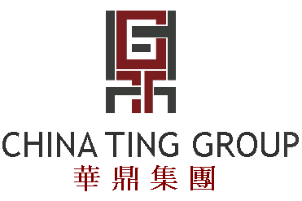

CHINA TING GROUP HOLDINGS LIMITED
華鼎集團控股有限公司
(Incorporated in the Cayman Islands with limited liability)
(Stock code: 3398)

The board of directors (the “Board”) of China Ting Group Holdings Limited (“the Company”) announces that a meeting of the Board is proposed to be held on Tuesday, 98 Sptember 2008 at 411:0 p.m.at 28/F, Futura Plaza, 111-113 How Ming Street, Kwun Tong, Hong Kong, for the purposes of, inter alia, considering approving the interim results and announcement of the Company and its subsidiaries for the six months ended 30 June 2008, and the declaration of dividend, if any.

By order of the Board
China Ting Group Holdings Limited
CHENG Ho Lung Raymond
Company Secretary

Hong Kong, 27 August 2008

As at the date of this announcement, the Board comprises seven Directors, of which Mr. TING Man Yi
(Chairman), Mr. TING Hung Yi (Chief Executive Officer), Mr. DING Jianer and
Mr. CHEUNG Ting Yin, Peter are executive Directors, and Dr. CHENG Chi Pang, Mr. WONG Chi
Keung and Mr. LEUNG Man Kit are independent non-executive Directors.

七二年

黃善榕

七九十四

八爾

